BFE  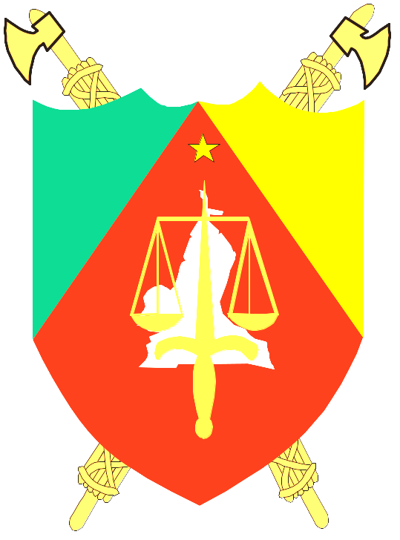  REPUBLIQUE DU CAMEROUN  Paix – Travail – Patrie  ----------  Présidence de la République  ----------  Commission Nationale Anti-Corruption  (CONAC)  Tél.: 222 20 37 32/658262682/651649194  Fax: 222 20 37 30/ Ligne verte 1517  B.P: 33 200 Yaoundé  N° 1500/0018/sc1/_____/CONAC/DPC/ST Yaoundé, the | REPUBLIC OF CAMEROON  Peace – Work – Fatherland  ----------  Presidency of the Republic  -----------  National Anti-Corruption Commission  (NACC) --------  Whatsapp : 658262682  URL : http://www.conac.cm  Mailto : info@conac.cm

PRESS RELEASE

The Chairman of the National Anti-Corruption Commission (CONAC), Reverend Doctor Dieudonné MASSI GAMS, informs the national and international public that the Institution will organise a “Corruption-free back-to-school” campaign in the ten Regions of Cameroon, from the 19th to the 24th of August, 2024.
The theme for this year's campaign is: “Let's work together for a corruption-free 2024-2025 school year”.
During this period, teams from CONAC will be visiting schools, decentralised services of the education sector and areas with a high population density, to sensitise the national education community on the need to avoid any corrupt practices in the education sector in general, and particularly during the sensitive period of the start of the new school year.
The official ceremony to launch the nationwide campaign will take place in the town of Akonolinga, Nyong and Mfoumou Division, in the Centre Region, on Tuesday 20th August, 2024.

Meanwhile, the Chairman of CONAC urges all stakeholders in the education sector to report any abuses they may be victims or witnesses of during this sensitive period of the beginning of the new school year to the following CONAC contacts:

WhatsApp : 658262682

Hotline : 1517

Email: info@conac.cm

Website: www.conac.cm

CONAC is always ready to listen. Contact them and they will do the rest.

Rév. Dr Dieudonné MASSI GAMS

Chairman

